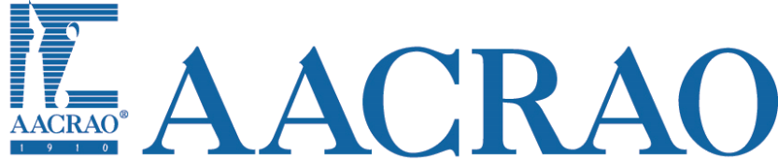

AACRAO Partnership and Affiliate Agreement

This Partnership and Affiliation Agreement (“Agreement”) is made and entered into by the American Association of Collegiate Registrars and Admissions Officers (“AACRAO”) and ___________________________________________ (“State or Regional Organization”)on ____________________, 2019 (“Execution Date”).

This Agreement sets out the terms and conditions that govern the partnership or Affiliation between AACRAO and the State or Regional Organization.

The State or Regional Organization named above has chosen to be an:
_______ AACRAO Affiliate
_______ AACRAO Partner

Based on the choice of designation as an AACRAO Affiliate or AACRAO Partner, the State or Regional Organization will have the following expectations (“expectations) and AACRAO will have the following expectations (“Opportunities”).

AACRAO Affiliate
Expectations
- Independently incorporated within home state (any state within region for regional based organization). In most states this includes an annual filing with the state Attorney General.
- Independent 501c3 status with the US Internal Revenue Service. Includes an annual filing of a form 990.
  - AACRAO will provide initial assistance for moving to 501c3 status
- Established bylaws that are reviewed periodically by the board or similar membership committee.
- Established non-discrimination statement that has been approved by the membership.
- Annual audit of organization finances either by a committee of the membership or an external organization.

Opportunities
- Ability to use the American Association of Collegiate Registrars and Admissions Officers (AACRAO) name and marks.
- Direct link to state or regional organization from AACRAO’s website.
- Marketing of state or regional sponsored event at AACRAO Annual Meeting (mention in program and other materials).
- Invitation to AACRAO Leadership Meeting.
- Invitation to AACRAO State and Regional Workshop prior to the Annual Meeting.
- Participation in free webinars through the year focused on running a state and regional organization and best practices.
- Free best practice and training materials through the year.
- Training and advisement on 501c3 and non-profit status.
- AACRAO board or staff member available to attend your state or regional meeting every 3 years.

AACRAO Partner
Expectations
Independently incorporated within home state (any state within region for regional based organization). In most states this includes an annual filing with the state Attorney General.
- Independent 501c3 status with the US Internal Revenue Service. Includes an annual filing of a form 990.
- Established bylaws that are reviewed periodically by the board or similar membership committee.
- Established non-discrimination statement that has been approved by the membership.
- Annual audit of organization finances either by a committee of the membership or an external organization.
- Share a membership list annually with AACRAO.
- Provide at least one article per year for an AACRAO publication or newsletter.
- Include information provided by AACRAO in state and regional newsletter (or similar publication).

Opportunities
- Ability to use the American Association of Collegiate Registrars and Admissions Officers (AACRAO) name and marks.
- Direct link to state or regional organization from AACRAO’s website.
- Marketing of state or regional sponsored event at AACRAO Annual Meeting (mention in program and other materials).
- Invitation to AACRAO Leadership Meeting.
- Invitation to AACRAO State and Regional Workshop prior to the Annual Meeting.
- Participation in free webinars through the year focused on running a state and regional organization and best practices.
- Free best practice and training materials through the year.
- Training and advisement on 501c3 and non-profit status.
- ACRAO board or staff member available to attend your state or regional meeting each year.*
- 25% discount for an instance of memberClicks (any service level).
- $1,000 credit towards MemberClicks service.
- Use of AACRAO Conference call tools.
- AACRAO will host up to 2 listserves per organization.

AACRAO Board Member Attendance at State or Regional Meeting or conference
AACRAO Board or Staff Member attendance at State or Regional meeting or conference.
- The affiliation or partnership does not guarantee a specific board member or staff member.
- Requests must be received 4 months in advance.
- AACRAO representative will be provided an opportunity to deliver an AACRAO & Federal Update based on the following options:
  - 30 minutes with all attendees (no concurrent sessions)
  - 60 minutes with all attendees (no concurrent sessions)
  - 60 minutes as part of a concurrent session
  - Similar opportunity based on session structure for a particular state or regional organization.
- AACRAO representatives are available for other presentations as well based on the interest of the state and regional organization.

Length of Agreement
This agreement will be in effect for five years from initial execution date. A State or Regional Organization may enter into a new agreement with AACRAO at any time to change their designation from AACRAO Affiliate to AACRAO Partner or vice versa.

Approved by:

________________________________ _____________________________
Signature Mike Reilly, Executive Director
AACRAO
_________________________________
Printed Name

_________________________________ ______________________________
Organization Date

_________________________________
Date

